Department of Technology, Management & Budget
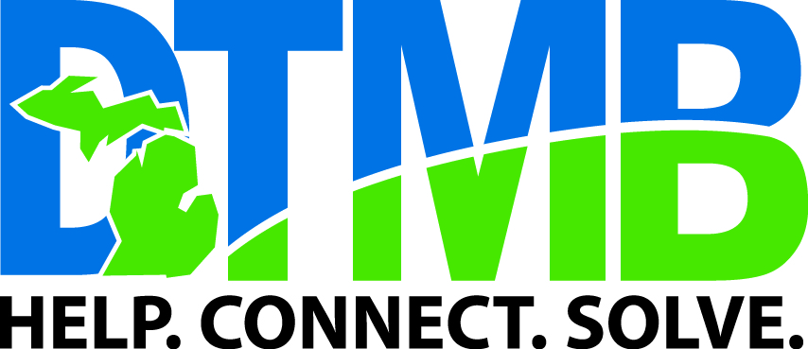

PRINTING SERVICES

BID REQUEST

JOB DESCRIPTION

Title: MDE Summer program - Yard Signs
Quantity: 1,500 of each | COMMENTS
Finish Size: 18 x 24 and 24 x 36 | Electronic file provided, one high resolution pdf proof required for approval.  Coroplast/Corregated Plastic Signs  2 Sided - Full Color - No Bleeds  H-Stakes included  *Vendor must attach a detailed quote letter(s). Failure to do so will result in bid disqualification.
Cover: Plastic Coroplast
Text:
Bindery: "H" Stakes
Packing: Skid Bulk Packed
File:
Sample:
Proof: Required

The Department of Technology, Management & Budget awards bids on best price and value to the state. In some situations, the lowest bidder may not receive an award because the bid does not provide best value. Examples include past quality concerns or inability to meet requirements. Only prequalified vendors will be considered.

